LAB 4
PROGRAM 4
Ant colony optimization – Job shop scheduling for manufacturing
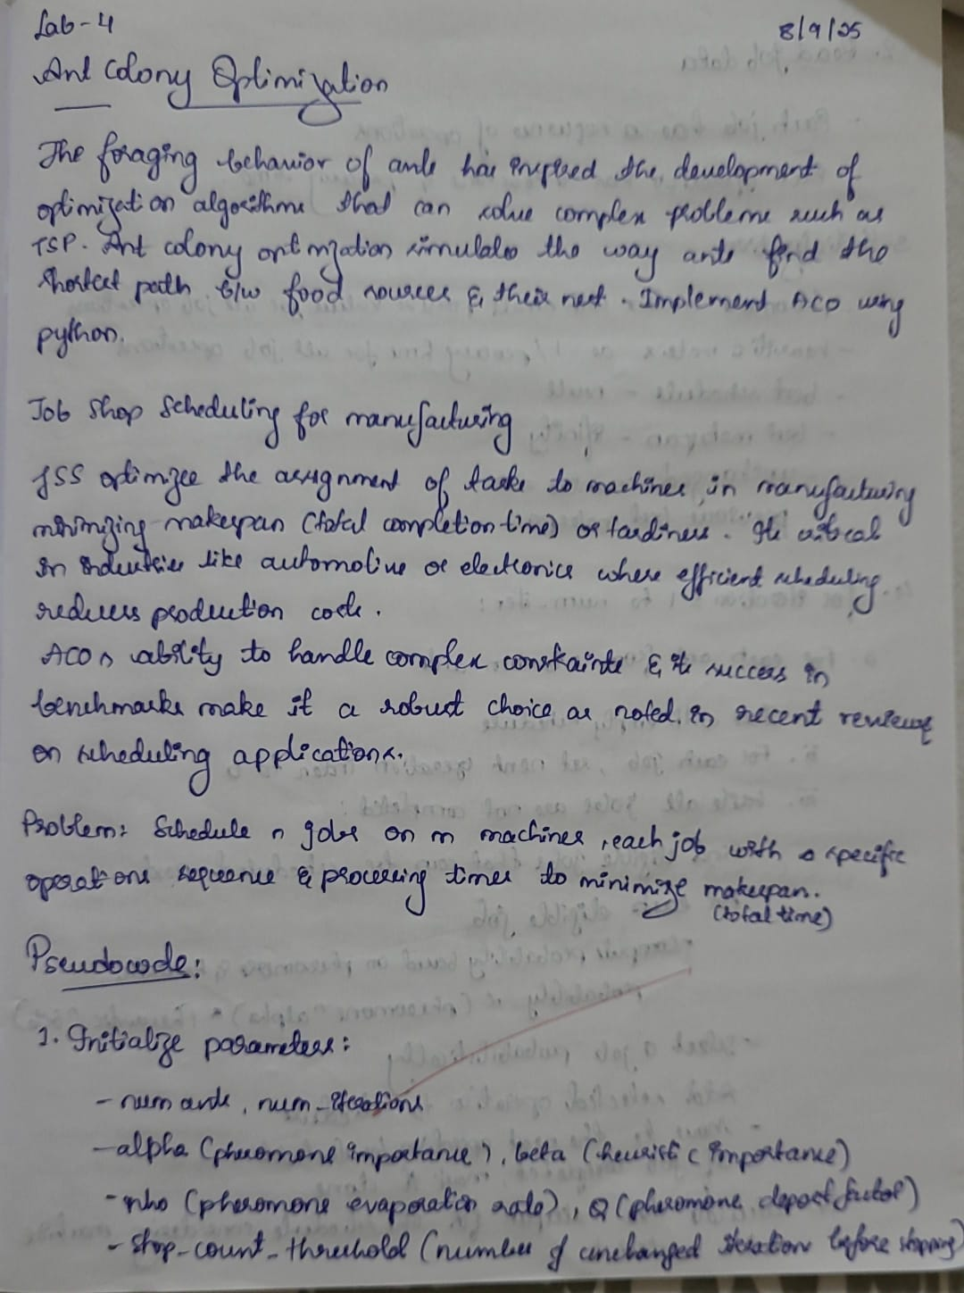
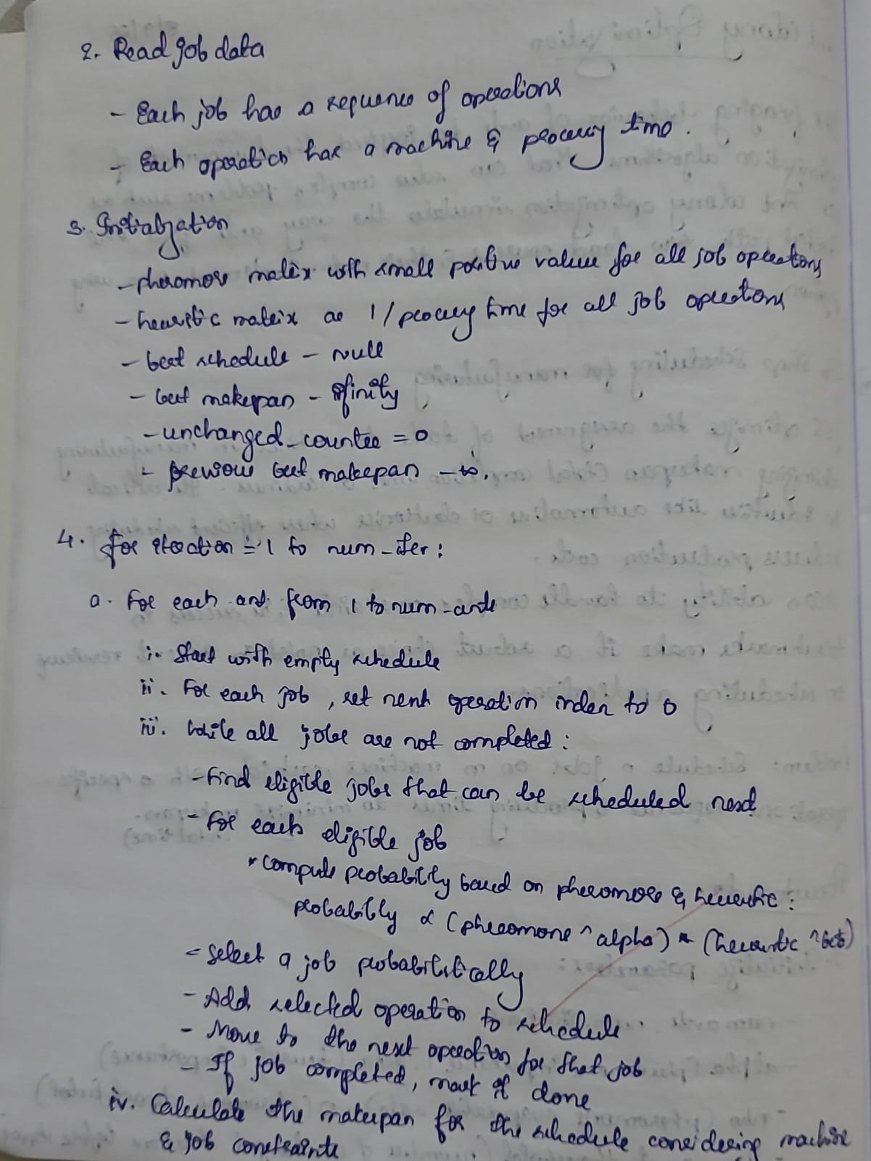

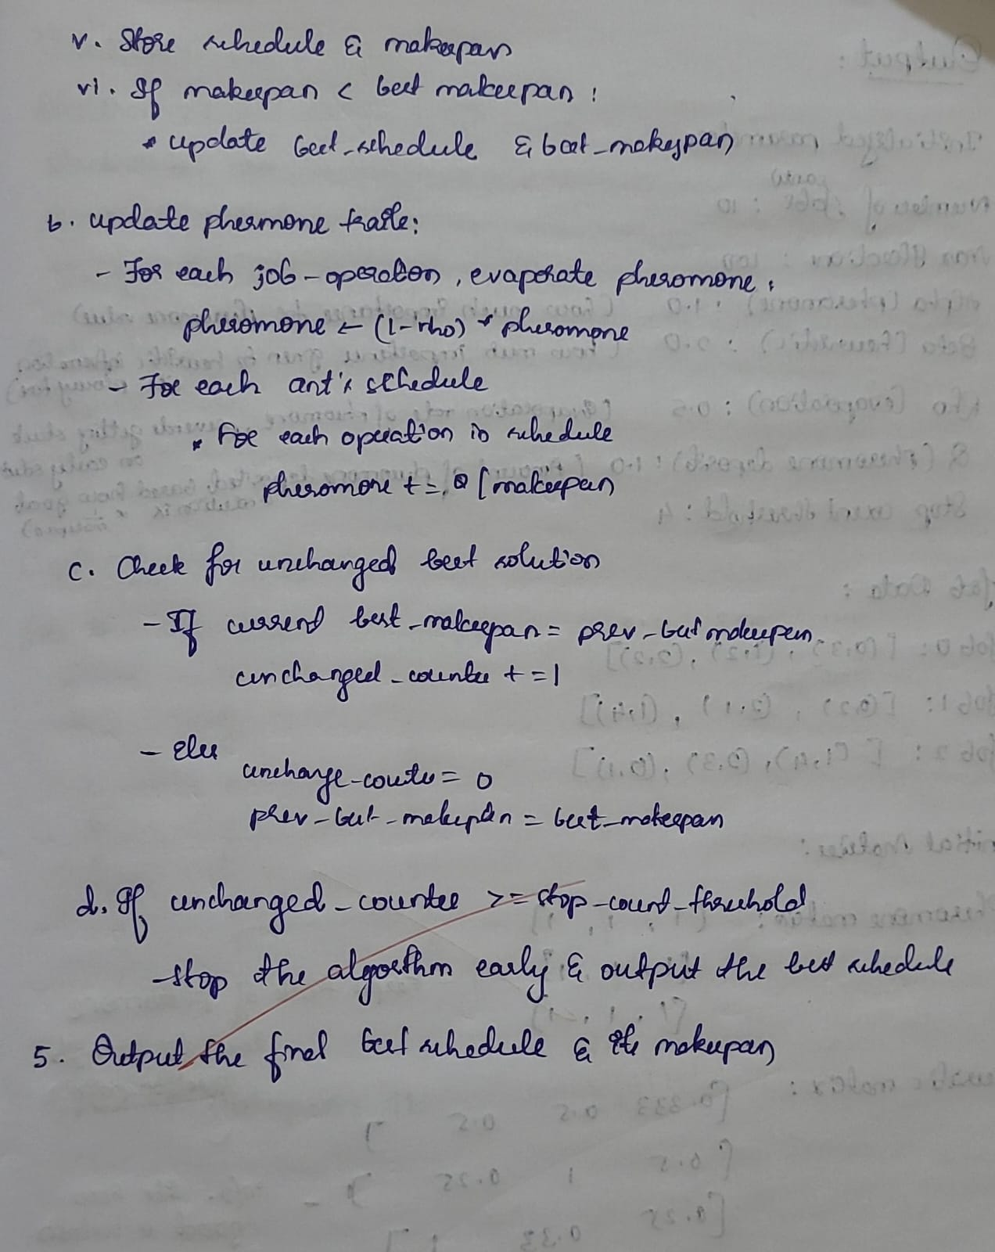

CODE:
import numpy as np
import random

# ------------------------
# PARAMETERS INITIALIZATION
# ------------------------

num_ants = 10 # Number of ants constructing solutions
num_iterations = 100 # Maximum number of iterations to run
alpha = 1.0 # Importance of pheromone
beta = 2.0 # Importance of heuristic (processing time)
rho = 0.5 # Evaporation rate of pheromone
Q = 1.0 # Amount of pheromone deposited based on solution quality
stop_count_threshold = 4 # Stop if the best solution doesn't improve for these many iterations

# ------------------------
# PROBLEM DATA
# ------------------------

jobs_data = [
[(0, 3), (1, 2), (2, 2)], # Job 0
[(0, 2), (2, 1), (1, 4)], # Job 1
[(1, 4), (2, 3), (0, 1)] # Job 2
]
num_jobs = len(jobs_data)
num_machines = 3

# ------------------------
# INITIAL MATRICES
# ------------------------

pheromone = np.ones((num_jobs, len(jobs_data[0]))) # Pheromone matrix initialized equally
heuristic = np.zeros((num_jobs, len(jobs_data[0]))) # Heuristic matrix based on processing time

for j in range(num_jobs):
for o in range(len(jobs_data[j])):
heuristic[j][o] = 1.0 / jobs_data[j][o][1] # Heuristic = 1 / processing time

# ------------------------
# TRACKING BEST SOLUTION
# ------------------------

best_schedule = None
best_makespan = float('inf')
unchanged_counter = 0
prev_best_makespan = float('inf')

# ------------------------
# PRINT INITIALIZED VALUES
# ------------------------

print("========== INITIALIZED PARAMETERS ==========")
print(f"Number of Ants : {num_ants}")
print(f"Max Iterations : {num_iterations}")
print(f"Alpha (pheromone) : {alpha}")
print(f"Beta (heuristic) : {beta}")
print(f"Rho (evaporation) : {rho}")
print(f"Q (pheromone deposit): {Q}")
print(f"Stop count threshold : {stop_count_threshold}\n")

print("========== JOB DATA ==========")
for job_id, operations in enumerate(jobs_data):
print(f"Job {job_id}: {operations}")
print()

print("========== INITIAL MATRICES ==========")
print("Pheromone Matrix:")
print(pheromone)
print("\nHeuristic Matrix:")
print(heuristic)
print("\nInitialization complete.\n")

# ------------------------
# INTRODUCTION
# ------------------------

print("This program applies Ant Colony Optimization to solve the Job Shop Scheduling problem.")
print("Ants build schedules using pheromone trails and heuristic information to find the schedule with the minimum makespan.")
print("The algorithm stops if the best solution has not improved for 4 consecutive iterations.\n")

# ------------------------
# FUNCTION DEFINITIONS
# ------------------------

def construct_schedule():
next_op = [0 for _ in range(num_jobs)]
completed_jobs = 0
schedule = []

while completed_jobs < num_jobs:
eligible_jobs = []
for j in range(num_jobs):
if next_op[j] < len(jobs_data[j]):
eligible_jobs.append(j)

probs = []
for j in eligible_jobs:
op_idx = next_op[j]
tau = pheromone[j][op_idx] ** alpha
eta = heuristic[j][op_idx] ** beta
probs.append(tau * eta)

total = sum(probs)
probs = [p / total for p in probs]

selected_job = random.choices(eligible_jobs, weights=probs, k=1)[0]
selected_op = next_op[selected_job]

schedule.append((selected_job, selected_op))
next_op[selected_job] += 1

if next_op[selected_job] == len(jobs_data[selected_job]):
completed_jobs += 1

return schedule

def calculate_makespan(schedule):
machine_times = [0 for _ in range(num_machines)]
job_times = [0 for _ in range(num_jobs)]

for job_id, op_idx in schedule:
machine_id, proc_time = jobs_data[job_id][op_idx]
start_time = max(machine_times[machine_id], job_times[job_id])
end_time = start_time + proc_time

machine_times[machine_id] = end_time
job_times[job_id] = end_time

return max(machine_times)

def update_pheromones(ant_schedules, ant_makespans):
global pheromone
pheromone = (1 - rho) * pheromone
for schedule, makespan in zip(ant_schedules, ant_makespans):
deposit = Q / makespan
for job_id, op_idx in schedule:
pheromone[job_id][op_idx] += deposit

# ------------------------
# MAIN ACO LOOP
# ------------------------

for iteration in range(1, num_iterations + 1):
ant_schedules = []
ant_makespans = []

for ant in range(num_ants):
schedule = construct_schedule()
makespan = calculate_makespan(schedule)

ant_schedules.append(schedule)
ant_makespans.append(makespan)

if makespan < best_makespan:
best_makespan = makespan
best_schedule = schedule

update_pheromones(ant_schedules, ant_makespans)

print(f"Iteration {iteration}: Best Makespan = {best_makespan}")

if best_makespan == prev_best_makespan:
unchanged_counter += 1
else:
unchanged_counter = 0
prev_best_makespan = best_makespan

if unchanged_counter >= stop_count_threshold:
print(f"\nBest solution unchanged for {stop_count_threshold} consecutive iterations.")
print("Stopping early.\n")
break

# ------------------------
# OUTPUT RESULTS
# ------------------------

print("========== FINAL RESULT ==========")
print("Best Schedule Found:")
for job_id, op_idx in best_schedule:
machine_id, proc_time = jobs_data[job_id][op_idx]
print(f"Job {job_id}, Operation {op_idx} on Machine {machine_id} for {proc_time} units")

print(f"\nOptimal Makespan: {best_makespan}")

OUTPUT:
